
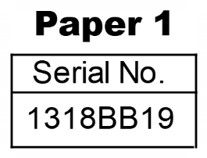
THE KENYA NATIONAL EXAMINATIONS COUNCIL
13229834
Kenya Certificate of Secondary Education
121/1 MATHEMATICS Alt. A
Nov. 2023 – 2 ½ hours

Name:…………………………………… Index Number: ………………..…………
Candidate’s signature: ………………………… Date: …………………………..….
Instructions to candidates:
- Write your name and index number in the spaces provided above.
- Sign and write the date of examination in the spaces provide above.
- This paper consists of two sections: Section I and Section II.
- Answer all the questions in Section I and only five questions from Section II.
- Show all the steps in your calculation, giving your answers at each stage in the spaces provided below each question.
- Marks may be given for correct working even if the answer is wrong.
- Non-programmable silent electronic calculators and KNEC mathematical tables may be used, except where stated otherwise.
- This paper consists of 18 printed pages.
- Candidates should check the question paper to ascertain that all the pages are printed as indicated and that no questions are missing.
- Candidates should answer the questions in English.
Examiner’s Use Only
Section I
1 | 2 | 3 | 4 | 5 | 6 | 7 | 8 | 9 | 10 | 11 | 12 | 13 | 14 | 15 | 16 | Total

17 | 18 | 19 | 20 | 21 | 22 | 23 | 24 | Total

Section II

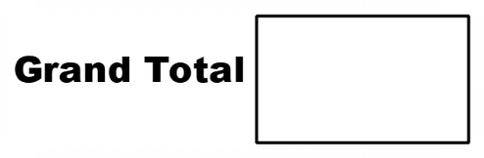

SECTTION 1 (50 marks)
Answer all the questions in this section in the spaces provided
- Without using a calculator, evaluate $\frac{-13+5-70÷5}{9-14x-13÷21}$ (3 marks)

- Simplify the expression $\frac{3a^{2}b^{-3}}{2^{-1}a^{-2b^{2}}}$ (2 marks)

- A triangle ABC is such that AB=11cm, BC=8cm and <ABC = 53º . Calculate the area of the triangle correct to 2 decimal places (2 marks)

- A cylindrical solid of radius 7 cm has a conical top of the same radius. The height of the cylindrical part of the solid is 17 cm. The conical top has a vertical height of 9 cm. Calculate the volume of the solid. $\left(Take π= \frac{22}{7}\right)$ (3 marks)

- Two light bulbs are set to light after every 40 seconds and 60 seconds respectively. If they light exactly at the same time initially, calculate:
- The time, in minutes, they will take to light together again. (2 marks)

- The number of times they would light together in the first half an hour. (1 mark)

- Solve the equation cos 2θ=sin θ for 0^{c} ≤ θ ≤$\frac{π^{c}}{4}$ . Leave the answer in terms of $π^{c}$.
(3 marks)

- Simplify and hence factorize the expression (5x-4y)(4x+5y)-9xy. (3 marks)

- From a point on top of a cliff 40m high, two boats A and B are observed due East. The angle of depression of boat A is 32º and that of boat B is 52º.
Determine the distance between the two boats, correct to 2 decimal places. (4 marks)

- In the following figure, triangle ABC is a uniform cross section of a solid ABCDEF. Given that BE is one of the edges of the solid, complete the sketch showing hidden edges with broken lines. (3 marks)

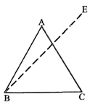

- A salesman sells story books and textbooks. The cost price of a story book is shs 600 while that of a textbook is shs 900, the salesman is paid a commission of 10% on the cost of any book sold. One day, the salesman sold twice as many story books as textbooks. He earned a commission of shs 8 400.
Determine the total number of story books sold. (3 marks)

- The equation of a curve is given by y=x2. Using the trapezium rule with 4 strips, estimate the area enclosed by the curve y = x2, the lines x=1, x=5 and the x-axis. (4 marks)

- Vectors a, b and c are represented on the following grid.

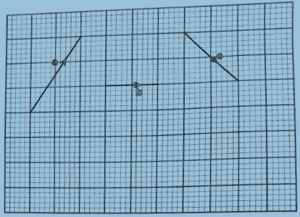
On the following grid, represent:
- The resultant vector a + b
- The resultant vector ( a + b)+c
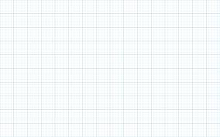

- Given matrix P =$\left(\begin{matrix}4 & 2 \\ -7 & -1\end{matrix}\right)$ , Q= $\left(\begin{matrix}-1 & 5 \\ 6 & -3\end{matrix}\right)$ and R = 20P⁻¹ + Q, determine matrix R.
(3 marks)

- In a sub county, the number of children per family was recorded from 30 families. The data recorded is as follows:
2 | 3 | 2 | 3 | 4 | 1 | 4 | 3 | 0 | 3
2 | 2 | 1 | 3 | 4 | 5 | 2 | 7 | 6 | 3
6 | 2 | 2 | 3 | 3 | 3 | 5 | 1 | 3 | 2

- Represent the data in a frequency distribution table. (1 mark)

- Calculate the mean number of children per family (2 marks)

- The equation of a curve is given by y = 3x²-2x. Determine the equation of a normal line to the curve at x = 2. (4 marks)

- On the following Cartesian plane provided, solve the simultaneous equations.
y = $\frac{4}{3}$x + 2
3y = x – 3

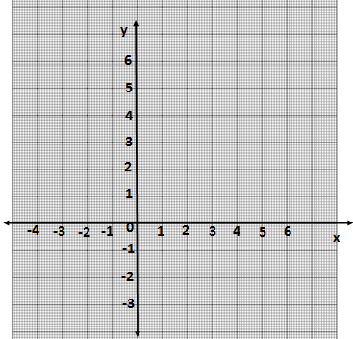

SECTION II (50 marks)
Answer only five questions in this section in the spaces provided.
- Two towns, A and B are 400 km apart. A motor cyclist travelling at an average speed of
60 km/h left town A for town B at 1.20 p.m. A matatu travelling at an average speed of 80 km/h also left town A for town B at 2.00 p.m.
(a) Calculate, the:
(i) distance covered by the motor cyclist by 2.00 p.m. (2 marks)

(ii) Distance from town A in km, where the matatu caught up with the motor cyclist. (3 marks)

(iii) Time when the matatu caught up with the motor cyclist. (2 marks)

(b) A lorry travelling at an average speed of 40km/h left town B for town A at 2.00pm. Determine the time when the lorry and the matatu met. (3 marks)

- On the following, triangle PQR is drawn.

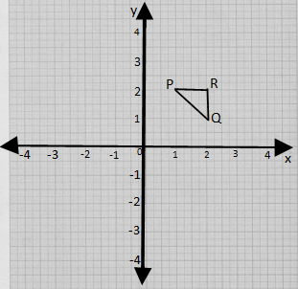

- On the grid, draw:
- Triangle P’Q’R’, the image of ∆PQR under a reflection in the line y=0. (2 marks)

- Triangle p’’Q’’R’’, the image of ∆P’Q’R’ under an enlargement scale factor -1.5, center 0. (3 marks)

- Triangle P’’’Q’’’R’’’, the image of $∆$ p’’Q’’R’’ under a half turn about 0. (2 marks)

- |Describe a single transformation that maps $∆P’Q’R’$ onto ∆ P’’’Q’’’R’’’. (3 marks)

- The following figure shows a right pyramid VABCD. The base ABCD of the pyramid is a square of side 8cm. The length of the slanting edges VA = VB = VC = VD = 10cm.

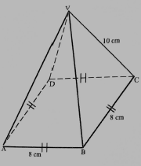
Calculate:
- The vertical height of the pyramid correct to 2 decimal places. (4 marks)

- Surface area of the pyramid (4 marks)

- Volume of the pyramid (2 marks)

- Neema went to the market to buy bananas worth Ksh 2100 for a school. The seller offered a discount of Ksh 3 per banana which enabled Neema to buy 35 more bananas.
- Taking Kshs x as the price per banana before discount, write an expression for the:
- Number of bananas that Neema would have bought before discount (1 mark)

- Actual number of bananas that Neema bought after the discount (1 mark)

- Form an equation in terms of x and hence determine the actual number of bananas Neema bought (6 marks)

- The bananas were given to students in a school. Two fifths of the students got 2 bananas each while the rest got a banana each. Determine the number of students in the school. (2 marks)

- The end of term test scores of 100 students was recorded as shown in the following table.
Scores | 30-39 | 40-49 | 50-59 | 60-69 | 70-79 | 80-98
No. of Students | 8 | 10 | 28 | 32 | 12 | 10

- State the modal class. (1 mark)

- Calculate the median score (3 marks)

- On the grid provided, represent the above data using a histogram.
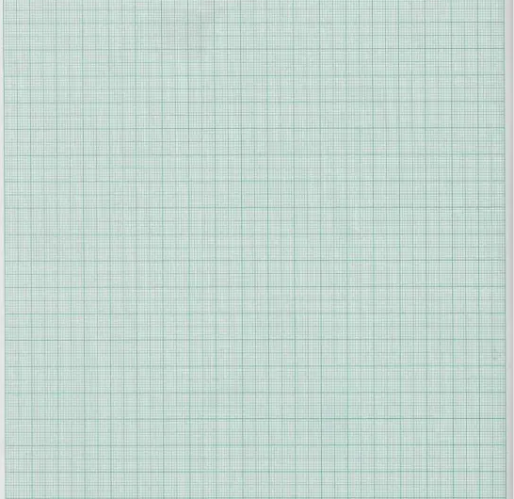

- Use the histogram to determine the number of students who scored from 71.5 to 76.5
(2 marks)

- The following figure shows a quadrilateral PQRS and a circle passing through the vertices P, R and S. Lines PQ = PR = 2.7 cm, PS = 6 cm, SR = 7 cm and <PQR = 65º .
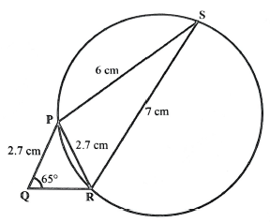
- Calculate:
- Length QR. (3 marks)

- <PRS (3 marks)

- Determine the area of the circle (4 marks)

- The displacement, x metres, of a particle moving a long straight line after t seconds is given by x = $\frac{t^{3}}{3}$ - 3 $t^{2}$ + 9.
- Determine:
- The values of t when the particle is momentarily at rest (3 marks)

- The values of displacement x metres by the time the particles comes to rest.
(2 marks)

- Determine the values of t when the velocity of the particle is -5 m/s. (3 marks)

- Determine the acceleration of the particle at t = 2 seconds. (2 marks)

- In this question, use a ruler and a pair of compass only.
Line PR is a diagonal of a quadrilateral PQRS. PR = 6cm.

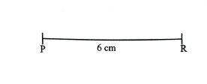

- Locate vertex Q of the quadrilateral PQRS such that <RPQ = 60º and RQ = 45º.
Complete triangle PQR and hence measure length PQ. (4 marks)

- Diagonal QS, which is 10 cm long, intersects with diagonal PR at right angle.
Complete the quadrilateral PQRS. (3 marks)
(c) Calculate the area of the quadrilateral PQRS. (3 marks)

